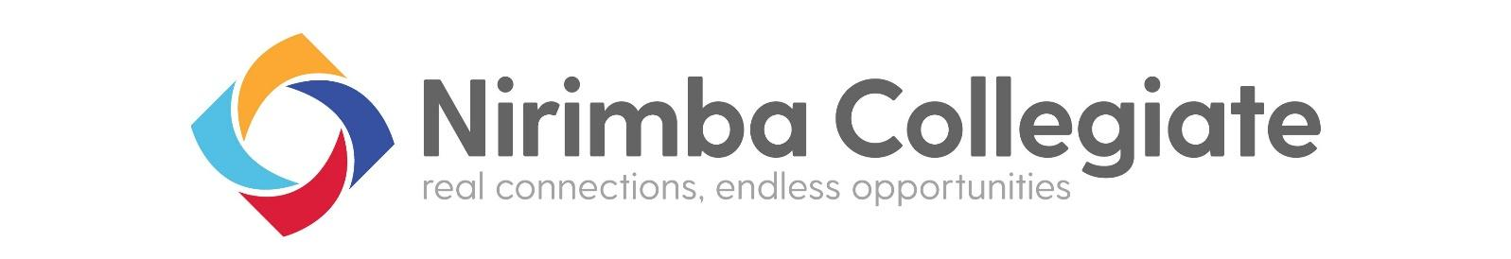
Year 11 2024 Subject Selection Process
Series of events to support year 10 students with subject selection.
Colour Key: Parent Events Student Events Paperwork or student survey Careers Advisers

Term 2 2023
Week 1 Careers Program commences including distribution of the Nirimba Collegiate Senior Course Guide. Lesson and information series to support the subject selection process. Schools post digital version of Senior Course Guide on their website. Collegiate Senior Course guides will be issued in a Year 10 Assembly/year meeting/careers lesson at QHHS, RHS & SHHS. Lesson series introduces - What is required for a HSC/ ATAR? Patterns of study explained to students. Categories of courses - A, B and Content Endorsed Subject selection timeline & process explained. What is in the Senior Course Guide?

Weeks 2-3 Collegiate Schools’ Open Nights.
Learn more about what the schools will offer senior students in 2024 and beyond. Stage 6 is unpacked for students and parents, including patterns of study, access courses, support structure for students selecting courses. Subject selection timeline and the date that subject selection closes. An evening of essential information for parents and year 10 students.
Quakers Hill High School Open Night – Tuesday 2nd May Riverstone High School Open Night – Wednesday 3rd May
Wyndham College Open Night – Tuesday 9th May Seven Hills High School Open Night – Wednesday 10th May

Week 2-3 Taster Day Survey
Students choose subjects to try out at the Senior Subject Taster Days. The survey and details to complete the survey is emailed in week 2. Students will have one week to select subjects in the survey. The survey will close on Friday 12th May so a timetable for the 6 subjects can be generated for Taster day. Students who do not complete the survey will have subjects chosen on their behalf by their careers teacher, to be chosen from any remaining subjects.

Week 6 Senior Subject Taster Days
Mon 29th May– SHHS/ RHS Senior Subject Day Tues 30th May – QHHS Senior Subject Taster
Hosted at Wyndham College on behalf of the Nirimba Collegiate – Students make their own way to Wyndham College for an 8am start in the Hall. The day will conclude at 2.30pm. Students will have selected subjects to ‘taste’ from the range of Collegiate courses on offer, and experience being a Year 11 student in 6 subjects during the day. Students will also have the opportunity to obtain course information at their current campus during weeks 5 to 7 and to touch base with their careers adviser.

Weeks 7-8 –Senior Subject Survey – Closes Tues 13th June
This online survey will provide information to create the curriculum structures for our four schools. From here the Curriculum grid is generated. This grid includes the subjects that each school will offer for year 11 2024, based on the results of the student survey.

Week 9-10 Students prepare for their Subject Selection Interview.
Students should take the time to reflect on information provided at Open Nights, read the information available in the Senior Course Guide (SCG), speak with Careers teachers, parents and subject teachers so that they are prepared to make their stage 6 selections. There will be no changes to final selections, reserves will be utilised where clashes occur or if courses do not run.
NOTE: students are most successful in years 11 and 12 when they choose courses that they are genuinely interested in.

Term 3 2023
Weeks 1-3 – Subject Selection Interviews
Careers teachers will notify students the date of their interview. Students will meet with a member of the Collegiate Careers Team to discuss their career planning and subject choices. Parents are invited to attend the interview. Students seeking enrolment at Wyndham College will have an enrolment package provided to them at the interview. Cross campus Access course applications may be made at this time. EVET applications can be initiated at this interview, but students are responsible for following up relevant paperwork and adhering to due dates. Support students will have individualised Transition Planning meetings during this term.

Week 6 –Friday 25th August 2023. Year 11 2024 subject selection is closed.
Any students who have missed interviews must complete their subject selections with their careers teacher. All students seeking enrolment at Wyndham College need to return their enrolment forms to Wyndham College by Friday 25th August 2023. Cross campus EOIs are closed. Schools commence timetable planning for 2024.
SUBJECT SELECTION CLOSES FRIDAY 25TH AUGUST 2023. No changes to subject selections after this date.

